SQL privileges

🔐 What Are Privileges in SQL?
# Source: AI Source: Provided by: [Data Path: Persons Table -> ID Column: 1, Name_En Column: Motasem Essam] -> From: [ChatGPT] on [6/11/2026]
In SQL, privileges (or permissions) define what actions a user is allowed to perform on the database or its objects (like tables, views, etc.).
They are part of Database Control Language (DCL).

✅ Common Types of Privileges
# Source: AI Source: Provided by: [Data Path: Persons Table -> ID Column: 1, Name_En Column: Motasem Essam] -> From: [ChatGPT] on [6/11/2026]
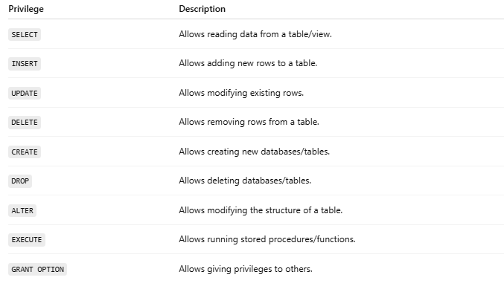
Privilege | Description
SELECT | Allows reading data from a table/view.
INSERT | Allows adding new rows to a table.
UPDATE | Allows modifying existing rows.
DELETE | Allows removing rows from a table.
CREATE | Allows creating new databases/tables.
DROP | Allows deleting databases/tables.
ALTER | Allows modifying the structure of a table.
EXECUTE | Allows running stored procedures/functions.
GRANT OPTION | Allows giving privileges to others.

🔑 Example:
# Source: AI Source: Provided by: [Data Path: Persons Table -> ID Column: 1, Name_En Column: Motasem Essam] -> From: [ChatGPT] on [6/11/2026]
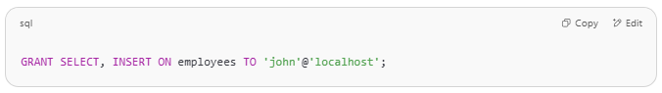
GRANT SELECT, INSERT ON employees TO 'john'@'localhost';

This gives user john the right to:
- Read data from the employees table
- Add new rows to the employees table

🧼 How to Remove Privileges:
# Source: AI Source: Provided by: [Data Path: Persons Table -> ID Column: 1, Name_En Column: Motasem Essam] -> From: [ChatGPT] on [6/11/2026]
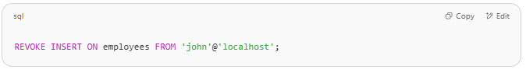
REVOKE INSERT ON employees FROM 'john'@'localhost';

💡 Privileges Can Be Granted On:
# Source: AI Source: Provided by: [Data Path: Persons Table -> ID Column: 1, Name_En Column: Motasem Essam] -> From: [ChatGPT] on [6/11/2026]
- Databases
- Tables
- Columns
- Procedures / Functions

